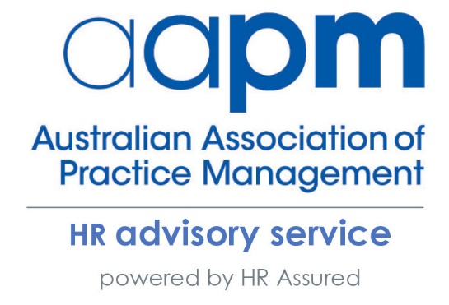

Fair Work Commission announces 2020 minimum wage decision
The Fair Work Commission’s Minimum Wage Panel (Panel) has handed down its minimum wage decision which increased the National Minimum Wage, together with all Modern Award minimum rates of pay, by 1.75%.
This year, The Panel was confronted with particularly challenging macroeconomic circumstances arising from the COVID-19 pandemic, including an anticipated fall in Australian GDP by up to 8% and significant increase in unemployment.
During the review process “sharply polarised” positions were put to the Panel. While the Government did not put an actual position it advocated a cautious approach with a primary objective of maintaining employment.
Employer and industry groups contended that minimum wages should either not increase, or increase at a later stage in the year – this was recommended as many employers are unlikely to be in a position to absorb any increase in labour costs which would adversely impact upon employment and the economic recovery.
While the Australian Council of Trade Unions acknowledged that employers in many industries are adjusting to significant reductions in consumer demand, it sought an increase of 4% to improve the living standards of low paid workers and also act as a stimulus to the subdued economy.
Taking these submissions into consideration, the Panel reasoned that:
- The outlook remains very uncertain;
- The shock to the labour market weights favourably in preserving employment;
- The Panel must also consider the relative living standards and needs of the low paid;
- If no increase was awarded it would result in a real wage cut which would result in further disadvantage for the low paid;
- An increase of the size proposed by the ACTU would create a real risk of higher unemployment; and
- The prevailing economic circumstances and pathway to recovery warrant a cautious approach both in terms of the quantum and timing of the increase.
Upon this basis, and while acknowledging the very difficult macroeconomic circumstances, the Panel determined that a 1.75% increase was justified and necessary in the circumstances which will result in the National Minimum Wage will increase to $753.80 per week, or $19.84 per hour.
The Panel has considered that there are exceptional circumstances which justify a delay in the commencement of the increase. While COVID-19 has substantially impacted the economy, the Panel notes that the impact has been inconsistent and not all industries have been impacted evenly. The differential impact of the pandemic required a more “nuanced approach” to the timing of the increase and as such the Panel has determined to implement the increase in stages as outlined below:
Group | Start Date | Industry Sectors
Group 1 | 1 July 2020 | - Frontline heath care and social assistance workers  - Teachers and child care workers  - Other essential services
Group 2 | 1 November 2020 | - Construction  - Manufacturing  - A range of other industries
Group 3 | 1 February 2021 | - Accommodation and food services  - Arts and recreation services  - Aviation  - Retail trade  - Tourism

The Health Professionals and Support Services Award 2020 and Nurses Award 2010 are listed as Group 1 Award meaning that increases to minimum rates of pay will apply from the first full pay period after 1 July 2020.
What this means for you
Modern Awards
Employers who pay their employees at the National Minimum Wage or Modern Award rates of pay will need to apply the increase from 1July 2020. Further information as to the dates for the increase and impacted groups will be provided in due course.
Annualised Salaries and Individual Flexibility Agreements
If you have implemented Individual Flexibility Agreements, you will need to reassess those agreements to ensure employees remain ‘better off overall’ when compared to the newly increased Modern Award rates. Employers who use annualised salary arrangements will need to conduct an audit of those annualised salaries against the new Award rates and working patterns to ensure the annual salary compensates for award entitlements.
Enterprise Agreements
The new Modern Award rates will also form the baseline for ‘better off overall’ testing new Enterprise Agreements (EA). If you have an EA in place, you will need to ensure the minimum base rates in the EA remain at a minimum equal to the new Modern Award rates. If not, EA rates will need to be increased to match the Modern Award.
Allowances
Today's decision will impact some allowances as well as base rates. A number of Modern Award allowances are expressed as a percentage of the ‘standard rate’, which is linked to the wage rate of a specific classification in the Award. These allowances will therefore increase in line with the increase in the standard rate.
Need help?
HR Assured appreciates the challenging economic environment in which businesses are currently operating and can help you understand how this decision affects your business. We can explain how minimum wages work, auditing and calculating pay rates and assisting you with implementing an appropriate strategy.
If you would like assistance with any of these matters, call the AAPM HR Advisory Service on 1800 196 000.

