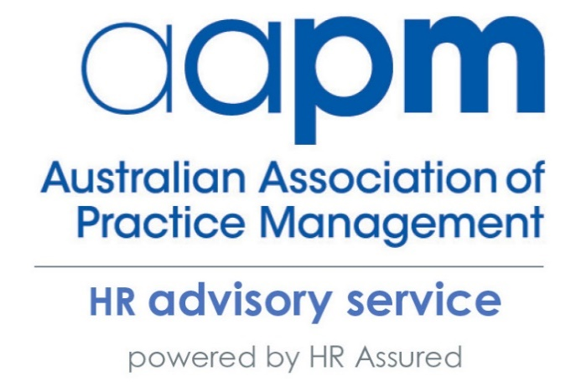

For more information or assistance please contact the AAPM HR Advisory Service
Phone: 1800 196 000
Email: HRadvisoryservice@aapm.org.au

If you have any questions regarding the fact sheet, please contact the AAPM HR Advisory Service for further information.

What is a day?

What is a day? How Cadbury workers win for sick leave could impact Australian employers

Two Tasmanian Cadbury workers, Brendan McCormack and Natasha Tewson, represented by the Australian Manufacturing Workers Union (AMWU) have won a Federal Court case brought by the chocolate maker's parent company Mondelez over their sick leave entitlements, in a determination that is expected to have ramifications across Australia.
Under section 96(1) of the Fair Work Act 2009 (Cth) (FWA), it states, ‘for each year of service with his or her employer, an employee is entitled to 10 days of personal/carer’s leave.’ This provision may be expressed simply but its interpretation is quite complex. What does ‘a day’ actually mean?
The issue of ‘what is a day’ arose out of an application to approve the Mondelez Australia Pty Ltd, Claremont Operations (Confectioners & Stores) Enterprise Agreement 2017 (Mondelez Agreement). The Mondelez Agreement applied to shiftworkers working 12-hour shifts and the Commission expressed concerns that these employees would not be entitled to their full 10-day entitlement under section 96 FWA. This is because traditionally ‘a day’ has been taken to mean 7.6 hours (a normal working day) and using this historical approach would mean that shiftworkers who work extended hours would only receive 7.6 hours of personal/carer’s leave rather than 12 hours which represents their 12 hour rostered shift.
Mondelez submitted to the Federal Court that the entitlement provided for within section 96 of the FWA should be constructed according to the industrial meaning of the word day. That is a ‘notional day’ consisting of an employee’s average daily ordinary hours based on an assumed five-day working week—that is, average weekly ordinary hours divided by five. For example, an employee who works 38 ordinary hours per week works an average of 7.6 hours per day over an assumed five-day working week giving them a total of 76 hours of personal/carers leave per year.
Conversely, the AMWU constructed the entitlement as a ‘calendar day’ entitlement, or a 24 hours period, and that the provision within the FWA allows every employee to be absent from work without loss of pay on 10 calendar days per year. Effectively arguing that a 12-hour shift worker employee is entitled to more hours of paid personal/carer’s leave than the 7.6-hour employee, but neither would lose income over a period of 10 calendar days.
The Federal Court ruled in favour of the AMWU and the workers in a split decision. The practical effect of this decision effectively means where workers are working above the average of ordinary hours per day they would be entitled to more hours of personal/carers leave. For example, 12-hour shift worker would have their personal/carer’s leave paid at 12 hours per day.
Unions have heralded the decision as a great win for workers who work long shift that are longer than the standard day and ensures they are given an entitlement to enough personal/carers leave that is reflective of the hours they work. However, this decision poses a very real threat to substantial cost implications for businesses.
In light of this decision, businesses should be aware of the following:
  - Where personal/carer’s leave and/or annual leave entitlements are expressed in an enterprise agreement or an employment contract in terms of hours per annum rather than in days, employers may need to ensure that they have a mechanism for this leave entitlement to be ‘topped up’ for any shift workers who work in excess of 7.6 hour shifts.
  - If using payroll systems to calculate leave entitlements employers should consider checking whether employees are accruing entitlements on an hourly or daily basis. If shift workers are accruing entitlements on an hourly basis, adjustments may need to be made to ensure workers are receiving their lawful entitlements under the FWA.

If this represents a departure from the manner in which personal/carer's leave has been managed in your business, this could result in a systemic underpayment issue which will require redress. For further advice please phone the AAPM HR Advisory Service on 1800 196 000.

